Auxintech

Get It Done.

1. Portfolio

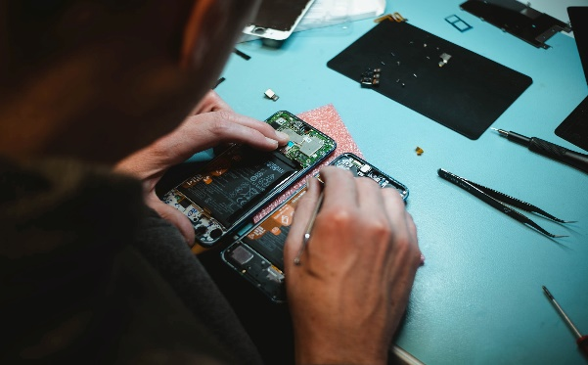

2.About US

**AuxinTech is solution to modern problems, we take care of your important and beloved devices whether it's your Laptop or your Best friend smartphone, we take away all the hassles of laptop repair services with its transparent pocket friendly  rate card . We pick->repair->drop your Laptop/Smartphones,  And most important we offer peace of mind.**

**We also sell all types of accessories for your laptop and smartphone.**

Brands

Apple, Samsung, Acer, Sony, Lenovo, Asus, Dell, HP, Vivo, Oppo, realme OnePlus, LG, MI, Moto

3.OUR SERVICES

Online assist - Our customer service will make sure your time, energy and money is saved for some extent.

Software Installations - We install all type of Software’s with license like Adobe S/Ws, Windows OS, Mac OS, Linux, AutoCAD......

Computer Repair - No matter what brand you use, what version you use, we repair/handle it all with care.

Troubleshooting - Stuck with lagy or slow device? Using laptop with difficulty? No issue will fix it for you.

Upgradation - Are you a gamer or a programmer? Do you want to boost your device performance with mods or upgrade/optimize the hardware/software? We do it all.

Mobile Service - We live in a modern world where smartphone plays a major role if used previously, we make you that your phone is well serviced and is in a month condition.

Doorstep Service - we pickup->service->drop your device if you are busy.

Laptop/Mobile accessories sale - we sell essentials for your device.

4.OUR SKILLS

Laptop/Computer - 100%

Mobiles - 95%

Software Installations - 99%

Troubleshooting - 99%

Customer Service - 100%

5.OUR HAPPY CLIENTS

A decent place to get the laptop repaired. My system had a display issue, they got it fixed before the expected time and they handed it back in a good condition.

Well mannered staffs, hygienic space, my phone was handled in a right way and got it repaired with lowest price possible.

Cheap and best place to get laptop repaired in Jayanagar, Worth for the Bugs.

Ran system diagnosis and gave right advise. Wasn't greedy and was ready for a 30 minutes turn around. Job well done

Went to buy laptop case and got SSD installed as suggested by a staff named Chethan because of which now my laptop is 3x faster.

Good service center, best costumer service, good

6.WHY AUXINTECH?

Rapid Repair

Doorstep Delivery

Handled with care

A+ Assistance

Quality Service

**8.Get In Touch**

9.OPENING HOURS

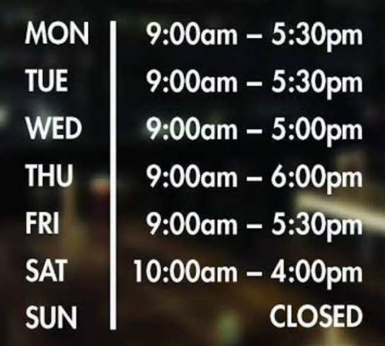

Monday - Friday 9:00am - 09:30pm

Saturday 10:00am - 09:30pm

Sunday 10:00am - 04:00pm

